**ITS290F Human Computer Interaction & User Experience Design**

**Lab 4. Bootstrap**

What you’ll learn in this lab:

* Bootstrap 4

**1. Bootstrap 4 Get Started**

What is Bootstrap?

* Bootstrap is a free front-end framework for faster and easier web development
* Bootstrap includes HTML and CSS based design templates for typography, forms, buttons, tables, navigation, modals, image carousels and many other, as well as optional JavaScript plugins
* Bootstrap also gives you the ability to easily create responsive designs

What is Responsive Web Design?

* Responsive web design is about creating web sites which automatically adjust themselves to look good on all devices, from small phones to large desktops.

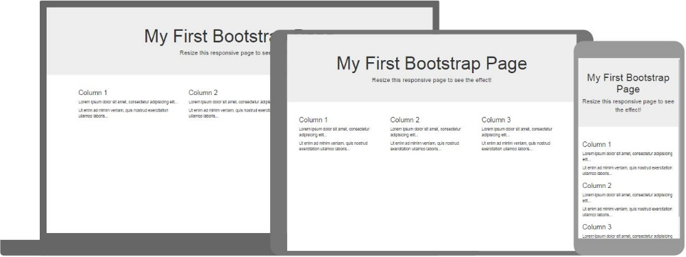

Why Use Bootstrap?

* Easy to use: Anybody with just basic knowledge of HTML and CSS can start using Bootstrap
* Responsive features: Bootstrap's responsive CSS adjusts to phones, tablets, and desktops
* Mobile-first approach: In Bootstrap, mobile-first styles are part of the core framework
* Browser compatibility: Bootstrap 4 is compatible with all modern browsers (Chrome, Firefox, Internet Explorer 10+, Edge, Safari, and Opera)

Where to Get Bootstrap 4?

* There are two ways to start using Bootstrap 4 on your own web site.
* You can:
  + Include Bootstrap 4 from a CDN
  + Download Bootstrap 4 from getbootstrap.com

**2. Readings**

Suggested readings from w3schools

1. Bootstrap 4 tutorial

<https://www.w3schools.com/bootstrap4/>

1. Bootstrap 4 Grid System

<https://www.w3schools.com/bootstrap4/bootstrap_grid_system.asp>

1. Responsive Web Design

<https://www.w3schools.com/css/css_rwd_intro.asp>

**3. Lab Exercises**

On your own, follow the instructions to finish the UI coding exercises. You may edit the code with any text editor. Put your solution code to the solution textboxes in the worksheet when finished.

**Exercise 1**

Download file **T04Ex01.html** and open it with a text editor (preferably Notepad++ if you use Windows). Study the code and answer the following questions.

|  |
| --- |
| 1. How many columns in the table? (Hints: see the td tags) |
| Your answer.  3 |

Then open the file **T04Ex01.html** with a recent web browser and try to resize the browser window and observe the layout changes of the web page elements, such as the heading, table and table columns.

|  |
| --- |
| 1. Try to squeeze the browser window (reduce the width) to mimic the screen size of a mobile phone. Do the table columns brake into rows? |
| Your answer.  No |

**Exercise 2**

Update the webpage in Exercise 1 to make it a responsive page with bootstrap supported. Make a copy of the file **T04Ex01.html** and name it as **T04Ex02.html**.

**Step 1.** Add metadata to declare the webpage is encoded in Unicode (UTF-8) and the viewport will be adjusted to fit in to the device-width of different devices. Put the following code excerpt inside the <head> section of the page:

<!-- Support Unicode content -->

<meta charset="utf-8">

<!-- Page width fits to device width -->

<meta name="viewport" content="width=device-width, initial-scale=1">

|  |
| --- |
| 1. What does initial-scale=1 mean in the meta tag? |
| It The initial-scale property controls the initial zoom level.  Initial-scale=1 means 1 Viewport pixel = 1 CSS pixel |

**Step 2.** Add support for Bootstrap 4. You can include it from a CDN (Content Delivery Network). MaxCDN provides CDN support for Bootstrap’s CSS and JavaScript. You must also include jQuery. Put the following code excerpt inside the <head> section of the page:

<!-- Latest compiled and minified CSS -->

<link rel="stylesheet" href="https://maxcdn.bootstrapcdn.com/bootstrap/4.5.2/css/bootstrap.min.css">

<!-- jQuery library -->

<script src="https://ajax.googleapis.com/ajax/libs/jquery/3.5.1/jquery.min.js"></script>

<!-- Popper JS -->

<script src="https://cdnjs.cloudflare.com/ajax/libs/popper.js/1.16.0/umd/popper.min.js"></script>

<!-- Latest compiled JavaScript -->

<script src="https://maxcdn.bootstrapcdn.com/bootstrap/4.5.2/js/bootstrap.min.js"></script>

**Step 3.** Apply simple *jumbotron-style* to the components in the first <div> section and align the text to *center* for drawing extra attention. Replace the first <div> tag with the follows:

<div class="jumbotron text-center">

**Step 4.** Next, we create a responsive container that change on different screen sizes/viewports. The container will then stores a grid that substitutes the original table. The grid contains a row with three columns and the width of each column tend to suit for the small screens.

1. Replace the <table> and </table> tags with:

<div class="container"> and </div> , respectively for creating a responsive container that stores a grid.

2. Replace the <tr> and </tr> tags with:

<div class="row"> and </div> , respectively for defining a grid row.

3. Replace the <td> and </td> tags with:

<div class="col-sm"> and </div> , respectively for defining a grid column for small devices. Note that there are three columns in the row.

**Step 5.** Save the file and view it on the web browser.

|  |
| --- |
| 1. Try to squeeze the browser window (reduce the width) to mimic the screen size of a mobile phone. Do the table columns brake into rows? |
| Your answer.  Yes |

|  |
| --- |
| 1. What is responsive web design? |
| Your answer.  Responsive web design is about creating web sites which automatically adjust themselves to look good on all devices, from small phones to large desktops. |

|  |
| --- |
| 1. Submit the <body> section of your solution **T04Ex02.html** file here. |
| <body>  <div class ="jumbotron text-center">  <h1>My First Bootstrap Page</h1>  <p>Resize this responsive page to see the effect!</p>  </div>    <div class="container">  <div class="row">  <div class="col-sm">  <h3>Column 1</h3>  <p>Lorem ipsum dolor sit amet, consectetur adipisicing elit...</p>  <p>Ut enim ad minim veniam, quis nostrud exercitation ullamco laboris...</p>  </div>  <div class="col-sm">  <h3>Column 2</h3>  <p>Lorem ipsum dolor sit amet, consectetur adipisicing elit...</p>  <p>Ut enim ad minim veniam, quis nostrud exercitation ullamco laboris...</p>  </div>  <div class="col-sm">  <h3>Column 3</h3>  <p>Lorem ipsum dolor sit amet, consectetur adipisicing elit...</p>  <p>Ut enim ad minim veniam, quis nostrud exercitation ullamco laboris...</p>  </div>  </div>  </div>  </body> |

**Exercise 3**

Now you have experience in creating a responsive web page. Next, we will create a responsive image gallery. The image gallery has a full width container (created by container-fluid class) that spans the entire width of the viewport. Insider the container, it has a header and a gallery of eight images in a 2x4 grid when displaying in a large screen and it will be shrank while displaying in smaller screens.

Here is the sample page:

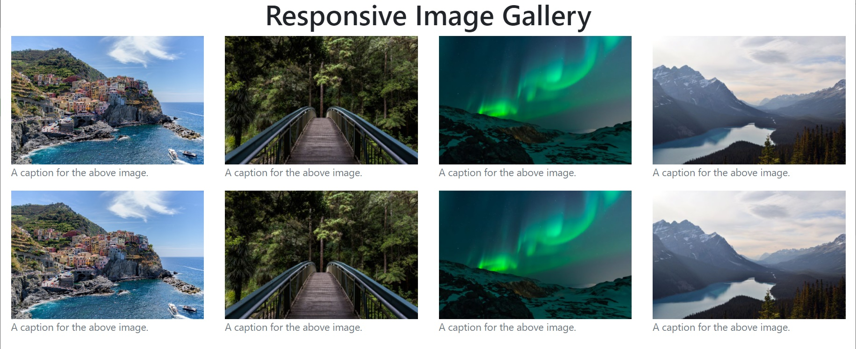

Download **T04Ex03.html** template page which has finished part of the code for you. It has a header and a grid of two images. Work on the template to create the page shown above. The image links of the other two images can be retrieved here:

<https://www.w3schools.com/css/img_lights.jpg>

<https://www.w3schools.com/css/img_mountains.jpg>

|  |
| --- |
| 1. Submit the <body> section of your solution **T04Ex03.html** file here. |
| <body>  <div class="container-fluid">  <h1 align="center">Responsive Image Gallery</h1>  <div class="row">  <div class="col-lg-3 col-md-6">  <figure class="figure">  <img class="img-fluid" src="https://www.w3schools.com/css/img_5terre.jpg">  <figcaption class="figure-caption">A caption for the above image.</figcaption>  </figure>  </div>  <div class="col-lg-3 col-md-6">  <figure class="figure">  <img class="img-fluid" src="https://www.w3schools.com/css/img_forest.jpg">  <figcaption class="figure-caption">A caption for the above image.</figcaption>  </figure>  </div>  <div class="col-lg-3 col-md-6">  <figure class="figure">  <img class="img-fluid" src="https://www.w3schools.com/css/img_lights.jpg">  <figcaption class="figure-caption">A caption for the above image.</figcaption>  </figure>  </div>  <div class="col-lg-3 col-md-6">  <figure class="figure">  <img class="img-fluid" src="https://www.w3schools.com/css/img_mountains.jpg">  <figcaption class="figure-caption">A caption for the above image.</figcaption>  </figure>  </div>  </div>  <div class="row">  <div class="col-lg-3 col-md-6">  <figure class="figure">  <img class="img-fluid" src="https://www.w3schools.com/css/img_5terre.jpg">  <figcaption class="figure-caption">A caption for the above image.</figcaption>  </figure>  </div>  <div class="col-lg-3 col-md-6">  <figure class="figure">  <img class="img-fluid" src="https://www.w3schools.com/css/img_forest.jpg">  <figcaption class="figure-caption">A caption for the above image.</figcaption>  </figure>  </div>  <div class="col-lg-3 col-md-6">  <figure class="figure">  <img class="img-fluid" src="https://www.w3schools.com/css/img_lights.jpg">  <figcaption class="figure-caption">A caption for the above image.</figcaption>  </figure>  </div>  <div class="col-lg-3 col-md-6">  <figure class="figure">  <img class="img-fluid" src="https://www.w3schools.com/css/img_mountains.jpg">  <figcaption class="figure-caption">A caption for the above image.</figcaption>  </figure>  </div>  </div>    </div>  </body> |

|  |
| --- |
| 1. In the HTML code, what does “col-lg-3 col-md-6” mean in the class of a column? |
| col-lg-3 means in large screen (like table) have 12 / 3 = 4 columns in a row  col-md-6 means in mid screen (like mobile phone) have 12 / 6 = 2 columns in a row |

|  |
| --- |
| 1. With the col-xx-yy class, what is the maximum number of columns in a row? |
| 12 |

|  |
| --- |
| 1. To display two images in a row on a large screen, which col class is the best choice? |
| Col-xl-2 |

**Submission**

You will get 0 to 3% of OCAS score upon completing the lab exercises.

1. Put your solution code inside the answer boxes and save the file.
2. Upload this file via the corresponding submission link on OLE.

**Note:**

1. The submission deadline is 23:59 of the forthcoming Thursday. The submission link will be closed after the deadline.
2. Your submission not necessary to be all correct but should show your efforts. We grade your work according to its quality.
3. Make sure you submitted a correct file. You can resubmit your work before the deadline.

1. DO NOT modify the layout and format of this document, and DO NOT save it as other file formats, i.e., PDF. Your work will be extracted using an automated document parsing tools for grading.

--- End ---